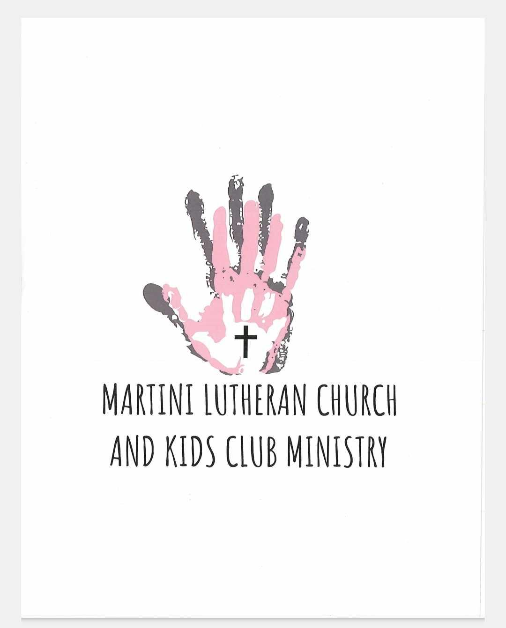

Martini Kids Club Ministry
Summer Camp 2026

Summer Camp Rates May 25th - August 7th, 2026
-Full Time (4 days or more) $195 per week
-Part Time (3 days or less) $145 per week
Annual Non-Refundable Registration Fee: $75.00 per child per year

(If your child is registered for the part-time option, there will need to be a set 3-day schedule, if you will need a flex schedule, one will need to be provided 2 weeks ahead of time. If a schedule is not submitted, you may not be guaranteed an opening for that day.)

⧫ Families will receive a 10% discount on their second (and additional) child(ren) enrolled at our facility. ⧫

⧫ Familes will receive a 10% discount for being active members
of Martini Lutheran Church, regardless of the number of children attending.

Martini Kids Club Ministry-Financial Agreement-2026 Summer Camp Registration

I _____________________________ agree to the following policies regarding tuition by initialing each statement and signing this agreement.

Child's Name: _________________________ Date: _____________________

____A non-refundable fee of $75.00 plus one week's tuition will be paid at the time of enrollment.
____The tuition for my child's care will be part-time $145/week or for full-time $195/week
____I understand that the registration fee is an annual fee and is automatically billed to my account the first week of May each year that my child is re-enrolled.
____A re-enrollment fee of $75.00 will be charged when a child is dropped from the program by the parent(s) or ministry and is re-enrolled at any time within the same year.
____If my weekly tuition is not paid by Friday at 6:00 pm, I understand that I will be charged a $10.00 late fee on the facility's next business day (Monday).
____A fee of $25.00 will be charged to my account if I have a check that has been returned/bounced.
____If my tuition becomes two weeks delinquent, I understand that my child will not be permitted to attend the Ministry's Childcare until my tuition is paid in full. At the end of those two weeks, if my tuition is not current, my child's spot may be given to another child on the waiting list.
____I understand that if a hot lunch is not purchased from Martini Kids Club for $2.50, a cold packed lunch is required each day and if one is not brought in, a $5.00 meal charge will be added to my account and Martini Kids Club will provide my child a hot lunch.
____I understand that if my child is sent home from the Ministry's Childcare due to a fever, that my child must be fever free without the help of medication for 24 hours before they are allowed to return.
____If my child is kept home from the Ministry's Childcare due to an illness or infection that may be contagious, I must provide a doctor's note stating my child is cleared to return, as well as that my child will not have any open/seeping wounds or sores.

____I understand that the Ministry's Childcare will be closed, and that tuition will be collected for the following holidays listed: Memorial Day, Independence Day and Labor Day. If a holiday falls on a weekend, it will be made up on the Friday before the holiday or the Monday after the holiday.
____I understand that the Ministry's Childcare will have up to 2 teacher in-service days that tuition will be collected for during the year. These two days will be the Friday prior to Memorial Day and the Friday prior to Labor Day.
____Martini Kids Club Ministry reserves the right to close due to unforeseen circumstances with as much notice as possible. Tuition will still be collected unless notified differently.
____The Ministry's Childcare hours are from 6:30 am to 6:00 pm. We close promptly at 6:00pm. If I arrive after this time, I understand that I will be charged a late fee based upon the time window below:
6:01 pm-6:15 pm $8.00 per child ⧫ 6:16 pm-6:29 pm $18.00 per child ⧫
6:30-Until picked up $18.00 + $3.00 per minute per child.

____A minimum of 2 weeks' notice will be given in writing when my child is to be withdrawn. If there is not two weeks' notice I will be charged the additional tuition to complete my two weeks' notice obligation.
____I have 30 days to pay any account balance in full after termination of care before being sent to collection.
____If collection of my tuition by a collection agency becomes necessary, I am liable for delinquent tuition, late fees, collection costs, court costs, and reasonable attorney fees.
____I understand that I must provide individual sunscreen for my child(ren) to be able to partake in outdoor play while at the Ministry's Child Care otherwise my child will remain inside.
____I am the parent or legal guardian of the above child and I accept full responsibility for payment for the above child. I have read and understand the above policies and procedures and understand that they will be followed:
Parent signature: ________________________________ Date: ________________


2026 Summer Camp Registration Continued
(Must fill out separate paperwork for each child)

Child's name: __________________________________ Date of Birth: __________________

Home Address: ______________________________________________________________________________________________________________________________________________________

Mother/Guardian Name: _______________________________________________________

Mother/Guardian Email: ________________________________________________________

Mother/Guardian Contact Number: _______________________________________________

Mother/Guardian Employer: ____________________________________________________

Father/Guardian Name: ________________________________________________________

Father/Guardian Email: ________________________________________________________

Father/Guardian Contact Number: _______________________________________________

Father/Guardian Employer: _____________________________________________________

Associated Church: ___________________________________________________________
Care Needed (please circle): FULL TIME or PART TIME Days Needed: (please circle below)

Monday Tuesday Wednesday Thursday Friday VARIES

(If your child is registered for the part-time option, there will need to be a set 3-day schedule, if you will need a flex schedule, one will need to be provided 2 weeks ahead of time. If a schedule is not submitted, you may not be guaranteed an opening for that day.)

Summer Camp Supply List
* Daily cold packed lunch, if not signed up for Martini Kids Club Hot lunch for $2.50 each meal. If a cold lunch is not brought in, a $5.00 meal charge will be added to my account and Martini Kids Club will provide my child a hot lunch.
*Bag that will be provided by Martini Kids Club Ministry on the first day of camp
and should only have a set of extra clothes, a towel and swimwear daily
Absolutely NO OUTSIDE TOYS or MATERIALS unless otherwise specified
*Water Bottle-Must have a lid or is able to close so that the mouthpiece is
covered.
*Individually labeled sunscreen with your child's name
*Active,comfortable clothes are required, that may get messy. Shoes are required to have a back on them. No spaghetti strap shirts or tube tops allowed.
***Remember: Please label ALL personal items with your child's first and last name. All creams or sunscreens to be applied require a completed medical authorization form and must be kept in their original packaging with your child's name on it. All prescriptions MUST be in their original packaging with the patient's name, dosage, and prescribed time to be administered. The doctor must complete a medical form (doctors note) before medication can be administered by a staff member at the Ministry's Childcare.
*There will be a maximum of 2 Electronic days scheduled during the summer. Information will be sent home so electronics can be sent in for those days only.

:
Martini Kids Club Summer Camp 2026
A Ministry of New Haven's Martini Lutheran Church LCMS

Notice Concerning Fire Safety Protection

Dear Parent(s) or Legal Guardian(s),

Under Indiana Law, a childcare ministry may choose not to provide certain fire safety protections if the parent(s) or legal guardian(s) of each child is/are notified about the absence of the fire safety protections. The purpose of this notice is to advise you that this childcare ministry does not have the same level of fire safety protection as a licensed childcare center. As you have already been notified, the childcare ministry does not have to comply with the same sanitation, life and fire safety rules as a licensed daycare center. The reason you are being given this notice is to inform you that the Martini Kids Club Ministry has chosen to abstain from installing fire alarm systems within the facility. This facility will use smoke detectors and will conduct monthly fire drills, as required by the state Fire Marshal.

I/We, the parent(s) or legal guardian(s) of _________________________
acknowledge that I/We have read and understand the above notice concerning fire safety protection

Signature Date

________________________________________ ___________________
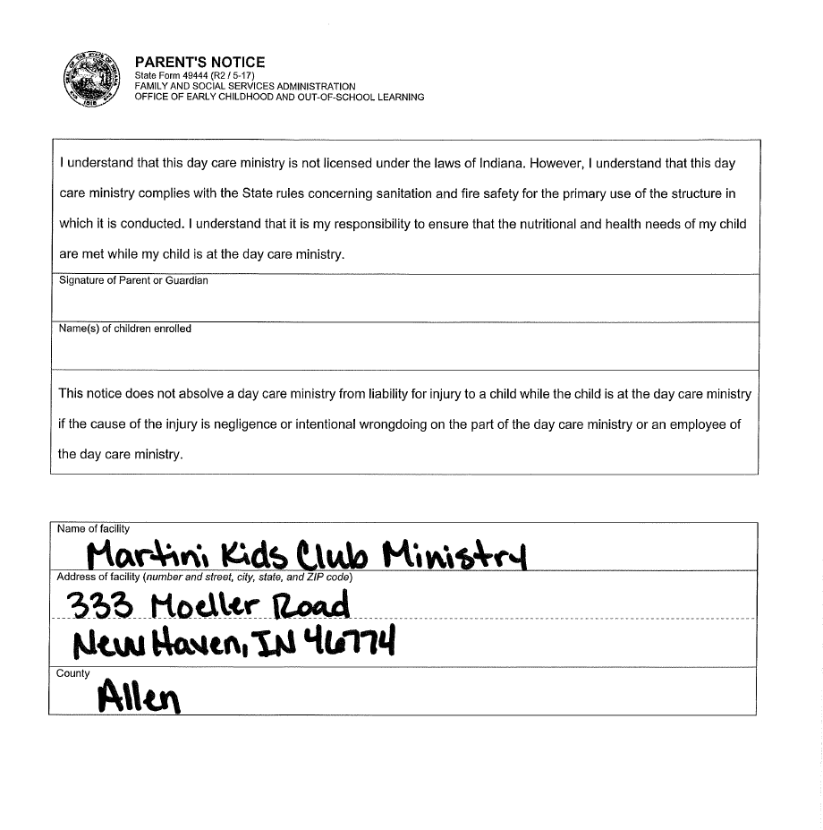
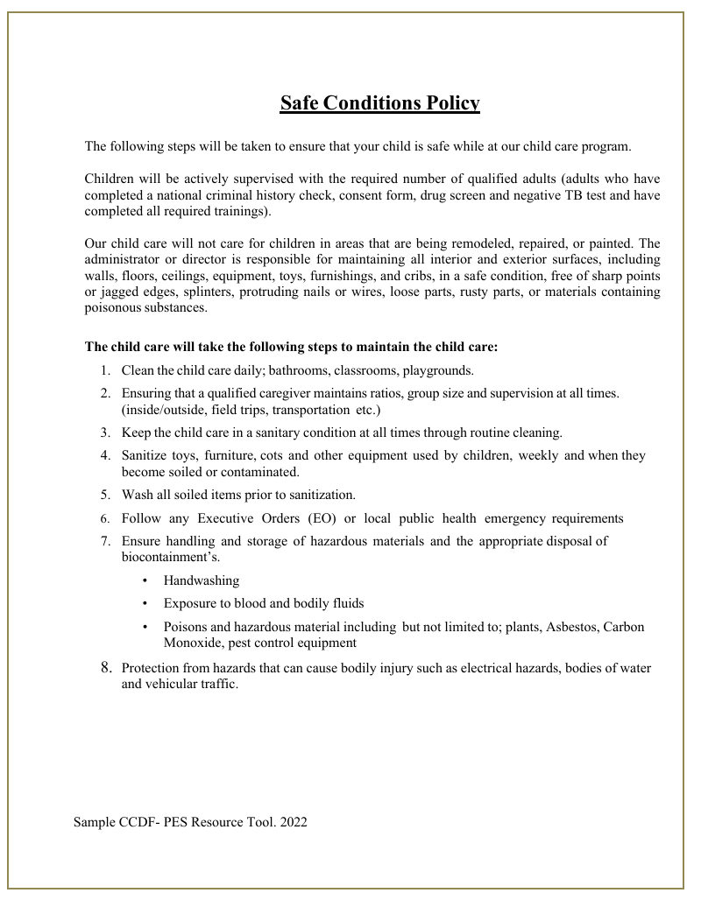

Martini Kids Club Ministry
Child Illness Policy
By signing below, you agree to always abide by the following child illness policy.

- I understand that Martini Kids Club Ministry does NOT provide ill childcare.
- I understand that if my child is deemed too ill to remain in the Ministry’s childcare, he/she will be expected to be picked up within a half hour of calling their parents.
- Any child with a temperature of 100.0 degrees or higher will be sent home from the facility’s care.
- Any child that has had a temperature of 100.0 degrees or higher, must remain home/out of the facility’s care until they have remained fever free for 24 hours without the use of any fever reduction medication.
- Any child who has vomited within the last 24 hours will be asked to remain home/out of the facility’s care until they are able to go 24 hours without vomiting and without the use of any medication.
- A child with repetitive diarrhea will be asked to be picked up or kept home from the facility’s care until he/she is symptom free for 24 hours without the use of medication.
- Any child with a rash will be asked to be picked up or kept home from the facility’s care until the rash has cleared, or until they have a doctor’s note stating they are not contagious and are clear to return to childcare.
- If your child is too ill to participate in the regular daily routines of the Ministry’s Childcare, he/she will be asked to be picked up and/or kept home from our care and asked to wait 24 hours before returning.

Please speak with one of the administrators for more information regarding our Child Illness Policy and to see the Communicable Disease Chart that Martini Kids Club Ministry uses to determine a child’s eligibility for returning to our care after becoming ill.

I understand that this policy is written with the best interest in mind for all the children in the care of Martini Kids Club Ministry and I agree to follow it accordingly.

Parent/Guardian Signature: ________________________________ Date: _______________

Emergency Contacts

The emergency contacts listed below can be contacted in the event of an emergency if I cannot be reached. They have authorization to pick up my child(ren) in the event of an emergency and may make medical decisions on my behalf until I can be reached.

- Emergency Contact Name: _______________________________ Relation to Child: __________________
Best Contact Number: ___________________________________
- Emergency Contact Name: _______________________________ Relation to Child: __________________
Best Contact Number: ___________________________________
- Emergency Contact Name: _______________________________ Relation to Child: __________________
Best Contact Number: ___________________________________

In case of an emergency in which my child needs immediate medical attention, I authorize my child to be transported by EMS to: ______________________________________________________

Please list any medical conditions we need to be aware of:
__________________________________________________________________________________________________________________________________________________________________________
Please list any medications your child takes on a regular basis:
__________________________________________________________________________________________________________________________________________________________________________
Please list any known drug allergies or any other allergies your child has:
__________________________________________________________________________________________________________________________________________________________________________

Dr. Name: _____________________________________ Phone Number:__________________________
Dentist Name: __________________________________ Phone Number: _________________________
Health Insurance Provider: _______________________________________________________________
Name of Policy Holder: __________________________________________________________________
Policy Number: ________________________________________________________________________
Insurance Contact Number: ______________________________________________________________

__________________________________________ ___________________________
Parent/Guardian Signature Date
-This form must be updated anytime there is a change in contact or medical information-
Martini Kids Club Ministry
Medication Permission Form

Child’s Name: __________________________ Date of Birth: _____________

This form gives Martini Kids Club Ministry Staff permission to administer the following non-prescription medications to the above-named child. All medications will be administered only with written permission from the child’s parent(s) with instructions for the dosage amount and time(s) to be given. Only medications provided by the parent(s) that are still in their original container will be administered.

MEDICATION | YES | NO
Tylenol (or generic)
Motrin (or generic)
Robitussin (or generic)
Dimetapp (or generic)
Benadryl (or generic)
Diaper Cream
Teething Gel
Sunscreen
Other:
_______________________

Special Instructions:
________________________________________________________________________________________________________________________________________________________________________

___________________________ __________________
Parent/Guardian Signature Date

-This form expires ONE YEAR from the above signed date-

Photography Consent Form
Dear Parent/Guardian,
As the parent of a child at Martini Kids Club Ministry, I agree to the following: I understand that my child whose name is listed below may be photographed while at the facility during normal childcare hours and other Martini Kids Club Ministry or Martini Lutheran Church events/activities. I understand that these photographs may be used/shared on your child’s class brightwheel accounts with other families and/or printed and displayed in the classroom. EXCLUDING SOCIAL MEDIA.
☐ YES — I give permission for Martini Kids Club Ministry to share my child’s picture through
brightwheel that would include other families at Martini Kids Club Ministry.
☐ NO — I do not give Martini Kids Club Ministry permission to share my child’s picture.

Child’s Name: _______________________________________________________

Parent Name:_________________________ Relation to child:________________

I give permission for my child to be photographed, or their images recorded for print/electronic use in promoting our childcare services via social media and our website. I understand that it is my responsibility to update this form if I no longer wish to authorize the above uses. I agree that this form will remain in effect during the term of my child’s enrollment with the facility. I understand that there will be no payment for me or my child’s participation.

☐ YES — I give permission for Martini Kids Club Ministry to share my child’s picture on our school
website, social media, or printed materials.
☐ NO — I do not give Martini Kids Club Ministry permission to share my child’s picture.

_______________________________ ______________________
Parent/Guardian Signature Date
Martini Kids Club Ministry
Pick Up Authorization (other than Mother and Father)

Child’s Name: ________________________ Date of Birth: ___________
The following person(s) other than the child’s guardians are authorized to pick up my child from the Ministry’s Care.
Name: ___________________________________ Contact Number: ______________________
Relationship to child: _____________________________________
Name: ___________________________________ Contact Number: ______________________
Relationship to child: _____________________________________
Name: ___________________________________ Contact Number: ______________________
Relationship to child: _____________________________________
Name: ___________________________________ Contact Number: ______________________
Relationship to child: _____________________________________
If there is a parent or legal guardian who is NOT allowed to pick up your child, we cannot stop them from doing so without a court order. Please supply a copy of the court order for your child’s file along with this information.

_______________________________________ _________________________
Parent/Guardian Signature Date

*Please let anyone on this list know they will be asked/need to show proper ID if it is their first time picking up, OR if a staff member from the facility does not recognize them.

It is very important that a child's development is nurtured through caring, patience and understanding. However, while caring for your children, I may have to respond to your child’s misbehavior. Hitting, kicking, spitting, hostile verbal behavior and other behaviors which will hurt another child are not permitted.
In response to these behaviors, I will not use:
· Threats or bribes
· Physical punishment, even if requested by the parent
· Deprive your child of food or other basic needs
· Humiliation or isolation
In response to misbehavior, I will:
· Respect your child
· Establish clear rules
· Be consistent in enforcing rules
· Use positive language to explain desired behavior
· Speak calmly while bending down to your child’s eye level
· Give clear choices
· Redirect your child to a new activity
· Move your child to a time-out chair for no longer than one minute per year of your child’s age, if necessary
If your child’s behavior is very disruptive or harmful to himself or other children, I will discuss the issue with you privately. If the situation can be resolved, the child may remain enrolled. If we are unable to resolve the issue, you may be asked to make other child care arrangements.
As a parent, you may have some concerns or wish to offer suggestions. Using the lines below, we may modify the above plan with agreed upon suggestions.
Child’s Name ____________________________________ Date of Birth __________________________
Additional techniques to be used with my child: ____________________________________________________________________________________________________________________________________________________________________________________________________________________________________________________________________________________
Parent/Guardian Signature ___________________________________ Date ___________________
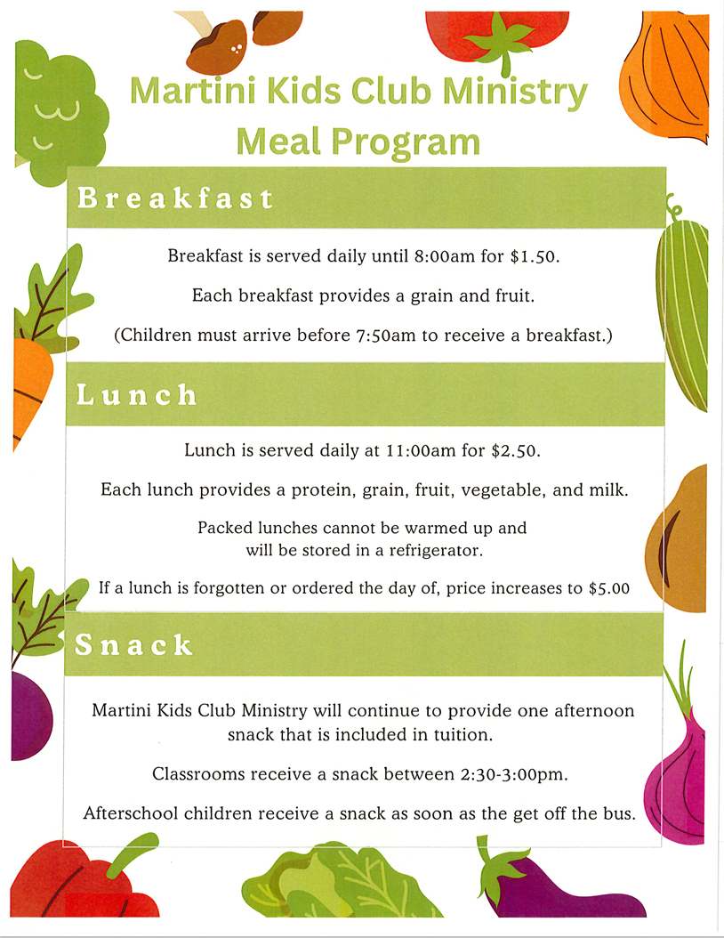

BUREAU OF CHILD CARE DIVISION OF FAMILY
RESOURCES SAFE TRANSPORTATION OF FOOD RESPONSIBILITY
Food must be brought to the facility in clean, insulated, sanitizable containers, which keeps cold food at 41° F or below and hot food at 135° or above. Containers must be clearly labeled with the child’s name and date of preparation. Upon receiving the food from the parent, the facility shall verify the temperature of the food. When potentially hazardous food temperature is not correct, the facility will not accept the food. Upon accepting the food, the facility shall maintain correct food temperatures until served.
PARENT AGREEMENT
I, _________________________________________(Parent’s name)
will provide food for____________________________ (Child’s name).

I take full responsibility for the safety of my child’s food during preparation, storage, and transportation to the facility.

(Parent’s Signature):________________________(Date):______________

